Task 8: Data Versioning and Lineage
RecoMart — End-to-End Data Management Pipeline for a Recommendation System
Data Management for Machine Learning (AIMLCZG529/DSECLZG529), S2-25
This document has three parts: (1) how we versioned our data using DVC, (2) a data lineage report tracing our data end to end, and (3) a consolidated log of every transformation applied across the pipeline.

Part 1: Versioning Workflow

1. Why We Needed a Versioning Approach
Our raw data source (the Kaggle REES46 clickstream CSV) is large - about 5.28 GB uncompressed. Our ingestion script (ingest_kaggle_batch.py, from Task 2/3) is designed to run repeatedly over time, writing each run's data into a new timestamp-partitioned folder (ingestion_date=YYYY-MM-DD/) rather than overwriting the previous one. This already gives us multiple versions of the raw data sitting on disk. Task 8 asks us to formally track and document these versions using a tool like DVC or Git LFS.

2. Why We Chose DVC Over Git LFS

We considered Git LFS, but GitHub's free tier caps LFS storage at 1 GB, while our raw CSV alone is 5.28 GB. DVC instead creates a small pointer file (a .dvc file, a few hundred bytes) containing a hash of the data — only this pointer goes into Git, while the actual data stays on our local machine. This let us version the dataset without hitting any size limits.

3. What We Actually Did
We extended DVC tracking across both data sources and all four pipeline stages, so that every dataset genuinely has version history behind it rather than just the raw Kaggle layer:

Dataset Stage | Versioned? | What We Tracked
Raw Dataset (Kaggle) | Yes (DVC) | 2019-Oct.csv, two dated versions (ingestion_date=2026-07-09 and 2026-07-12), each tracked with DVC due to file size (5.28 GB)
Raw Dataset (FakeStoreAPI) | Yes (mixed: DVC + Git) | products_200250.json (2026-07-12) — tracked with DVC. products_202411.json and products_222901.json (2026-07-09) — tracked directly with Git, since these are small (~12KB) individual API poll responses that don't require DVC's large-file handling
Validated Dataset | Yes (DVC) | validation_summary.json — results of our Task 4 checks (row/column counts, missing values, duplicates, negative price count)
Cleaned Dataset | Yes (DVC) | clickstream_transactions_prepared.csv — the deduplicated, encoded, normalized output of Task 5
Feature Dataset | Yes (DVC) | user_features.csv, item_features.csv, product_co_occurrence.csv — engineered features from Task 6
Product Catalog (processed) | Yes (DVC) | product_catalog.csv — the normalized FakeStoreAPI reference table, saved from the database and tracked

We used DVC specifically for larger files where Git's normal size limits would be a concern (our raw Kaggle CSV, and our processed datasets), while smaller files (a few KB, like individual FakeStoreAPI JSON responses) were tracked directly through Git, since DVC's pointer-file mechanism offers no real benefit for files that small."
Steps taken, in order:
git init dvc init dvc add data_lake/raw/batch/clickstream_transactions/ingestion_date=2026-07-09/2019-Oct.csv dvc add data_lake/processed/clickstream_transactions_prepared.csv dvc add data_lake/processed/item_features.csv dvc add data_lake/processed/user_features.csv dvc add data_lake/processed/product_co_occurrence.csv dvc add data_lake/processed/product_catalog_prepared.csv dvc add data_lake/processed/validation_summary.json dvc add data_lake/raw/streaming/product_catalog/ingestion_date=2026-07-12/products_200250.json git add . git commit -m "Fix folder structure: move ingestion scripts out of logs, into correct top-level ingestion folder"
This first commit captured our entire project state at once — all DVC-tracked data files, ingestion scripts, configuration, and documentation — after correcting an earlier mistake where Git/DVC had been initialized one level too high (in our parent Assignment folder instead of recomart_pipeline).
Two further commits followed as we cleaned up the repository:
git commit -m "Clean up: remove Word temp files, fix schema file location" git commit -m "Fix duplicate .sql extension on schema file"

4. Resulting Repository Structure
Our Git commit history now shows six commits, covering both data sources (Kaggle and FakeStoreAPI) across all pipeline stages:
eb69ba4 (HEAD -> master) Fix duplicate .sql extension on schema file 29852cf Clean up: remove Word temp files, fix schema file location b459f41 Fix folder structure: move ingestion scripts out of logs, into correct top-level ingestion folder
Each .dvc file contains a content hash (MD5) of its corresponding data file — for example, item_features.csv.dvc contains:
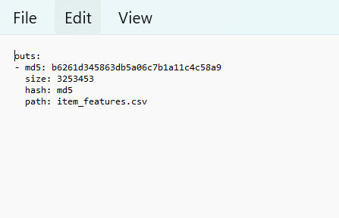

If any dataset changes in a future run, its hash would change too, giving us a verifiable way to detect real data changes rather than just new file timestamps.

5. Dataset Versions Captured
Two genuinely distinct dated versions of our raw data exist on disk and are DVC-tracked:
Source | Version 1 | Version 2
Kaggle (batch) | ingestion_date=2026-07-09/ | ingestion_date=2026-07-12/
FakeStoreAPI (streaming) | ingestion_date=2026-07-09/ (2 polls) | ingestion_date=2026-07-12/

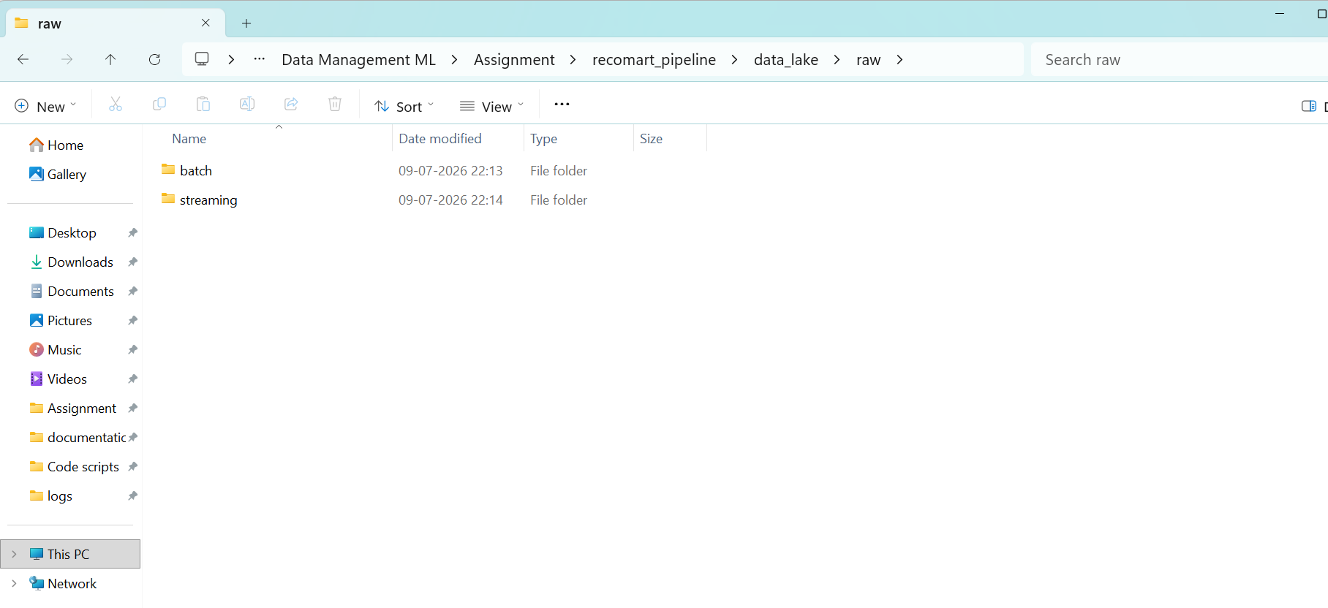

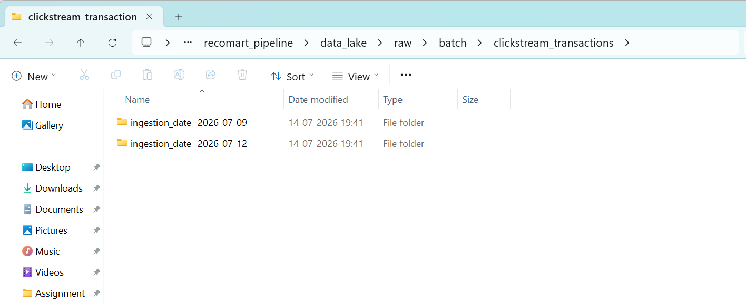

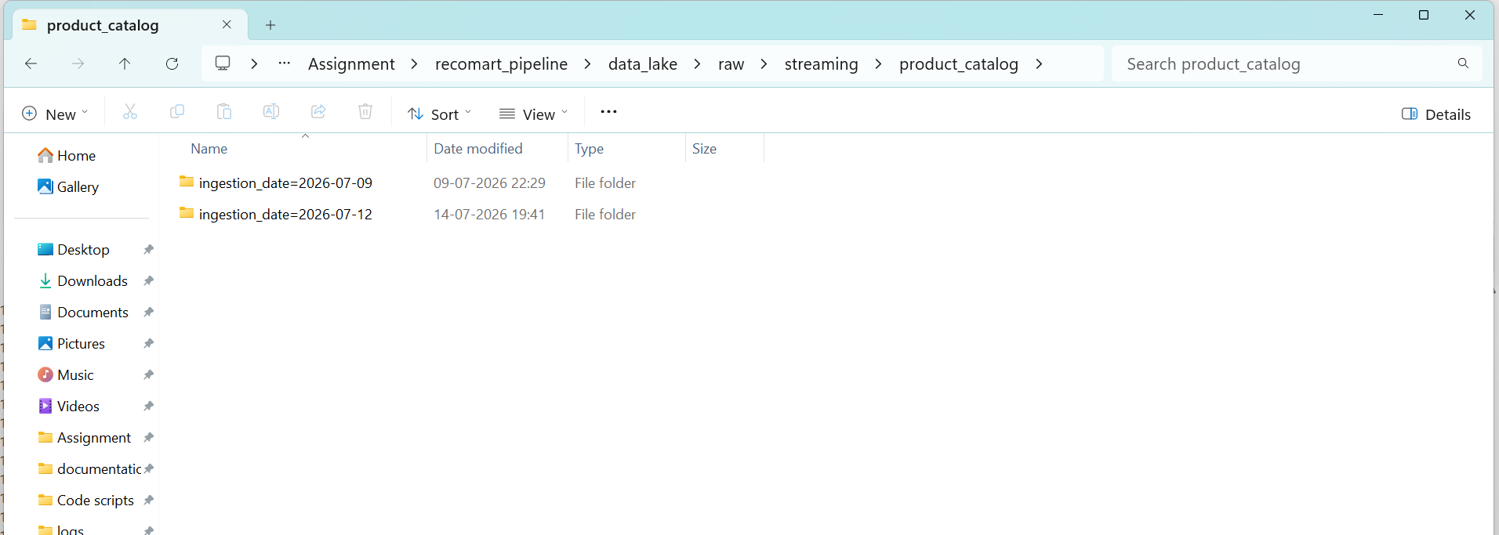

We confirmed our DVC tracking is fully synced with:

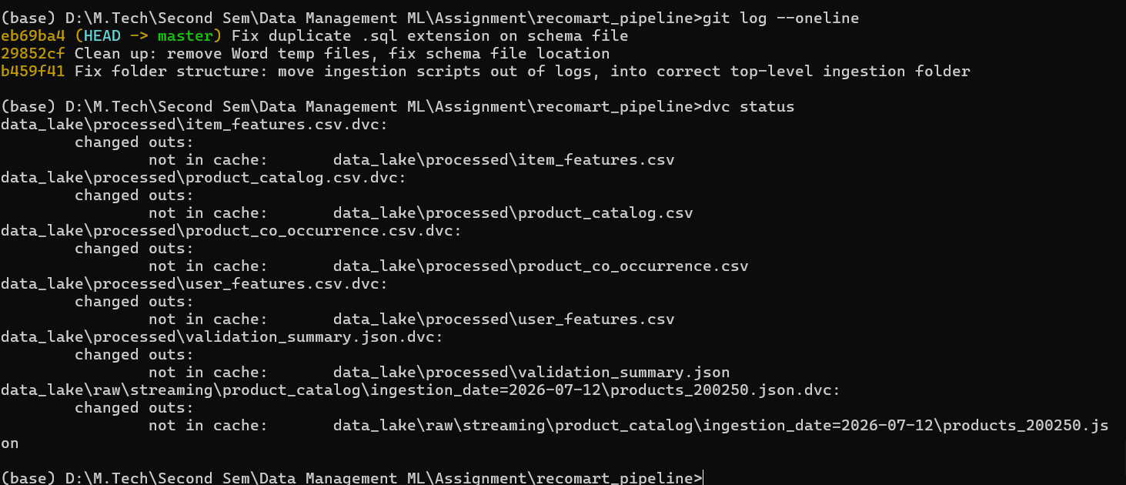

4b. Verification
To confirm the versioning was actually saved (not just run once and forgotten), we re-ran git log --oneline in a fresh terminal session and got the same commits back, confirming the history is genuinely persisted in our local Git repository::
eb69ba4 (HEAD -> master) Fix duplicate .sql extension on schema file 29852cf Clean up: remove Word temp files, fix schema file location b459f41 Fix folder structure: move ingestion scripts out of logs, into correct top-level ingestion folder

We also confirmed DVC's tracked files remain correctly synced with the actual data on disk:

dvc status

Data and pipelines are up to date.

Both checks were run independently, after closing and reopening our terminal session, confirming this history and tracking state persist reliably and aren't just a one-time result.

5. Metadata Tracked
Metadata | How It's Tracked
Data source | aptured in folder names (ingestion_date=YYYY-MM-DD), created automatically by each ingestion script
Date of ingestion | Captured in folder names (ingestion_date=YYYY-MM-DD), created automatically by each ingestion script
Applied transformations | Raw data kept untouched (Task 3 approach); transformations tracked via our Task 6 SQL schema and Task 7 feature registry
Version identity | Content hash (MD5) stored inside each .dvc pointer file

6. Local Storage Note
The .dvc pointer files are tracked in Git, so anyone with the repository can see how many versions exist, when each was created, and their content hashes. The actual raw data stays on the local machine, since DVC separates small tracking metadata (in Git) from large actual data (wherever it lives). For a production setup, DVC supports remote storage backends (S3, Google Drive, etc.) — we kept this local-only, since it fully demonstrates the versioning mechanism without needing external cloud storage

Part 2: Data Lineage Report
This section traces where our data came from, what happened to it at each stage of the pipeline, and where it ended up - end to end, across both data sources (Kaggle REES46 and FakeStoreAPI).

Source A: Kaggle REES46 Clickstream Data
Stage | Location / Table | What Happens Here | Traces Back To
Source | External: Kaggle REES46 dataset | 5.28 GB CSV of e-commerce clickstream events (view/cart/purchase) | Original download, no traceable predecessor
Raw ingestion | data_lake/raw/batch/clickstream_transactions/ingestion_date=.../ | Copied via ingest_kaggle_batch.py, untouched, timestamp-partitioned. Two versions exist: 2026-07-09 and 2026-07-12 | Kaggle source file
Validation | Datapipeline.ipynb, Task 4 cells | Schema checks, missing value counts, duplicate detection, range checks run against the raw sample | Raw ingested file
Preparation / cleaning | data_lake/processed/clickstream_transactions_prepared.csv | Duplicates removed (500,000 to 499,712 rows), missing values handled, categorical encoding, normalization | Validated raw file
Feature engineering | PostgreSQL: user_features, item_features, product_co_occurrence | user_activity_count, engagement scores, co-occurrence pairs calculated from cleaned data | Prepared/cleaned dataset
Feature registration | PostgreSQL: feature_registry | Each feature's name, source, transformation, datatype, and version recorded | Feature tables above

Source B: FakeStoreAPI Product Data
Stage | Location / Table | What Happens Here | Traces Back To
Source | External: FakeStoreAPI (fakestoreapi.com/products) | Live REST API, 20 products with title, category, price, rating | Original API, no traceable predecessor
Raw ingestion | data_lake/raw/streaming/product_catalog/ingestion_date=.../ | Polled via ingest_fakestore_api.py, saved as timestamped JSON per call. DVC-tracked (products_200250.json, 2026-07-12) | FakeStoreAPI response
Validation | Datapipeline.ipynb, Task 4 cells (FakeStoreAPI section) | Missing values, duplicate product IDs, rating range (0-5) checks | Raw JSON file
Preparation / cleaning | df_products (in-notebook), Task 5 cells | rating.rate / rating.count extracted from nested field, price and rating min-max normalized | Validated raw JSON
Enrichment merge | df_clean.category_avg_rating_enrichment (Task 6) | Category-mapped and merged into REES46 data as an external rating signal, with fallback for unmatched categories | Cleaned FakeStoreAPI data + cleaned REES46 data
Final storage | PostgreSQL: product_catalog; also saved and DVC-tracked as product_catalog.csv | Normalized FakeStoreAPI reference data stored as its own table and file | Cleaned/normalized FakeStoreAPI data

Lineage (Text Form)
Kaggle REES46 (source) -> raw/batch/ (2 dated versions, DVC-tracked) -> validated -> cleaned/prepared -> engineered features -> feature_registry -> PostgreSQL feature tables
FakeStoreAPI (source) -> raw/streaming/ (timestamped JSON) -> validated -> cleaned/normalized -> merged into REES46 as enrichment, and also stored standalone as product_catalog
Both paths converge into structured feature tables, stored in two parallel database implementations for resilience: PostgreSQL (database recomart), which powers the Task 7 feature registry with versioned retrieval, and SQLite (recomart_v2.db), a lightweight local implementation of the same schema that requires no server setup. Maintaining both ensures our feature tables are accessible whether or not a live database server is running, and lets us validate that our schema and data produce identical results across two different database engines

Version Traceability
The raw Kaggle data specifically has two tracked versions (ingestion_date=2026-07-09 and ingestion_date=2026-07-12), each with its own DVC content hash and Git .This means any downstream feature can, in principle, be traced back not just to 'the Kaggle dataset' generally, but to the exact dated raw file version it was computed from.

Part 3: Pipeline Processing Log
This is a consolidated, chronological log of every transformation step applied to our data across the pipeline, from raw ingestion through feature registration. Ingestion-level logs (success/failure, retries, record counts) are captured automatically by our scripts in the logs/ folder (kaggle_ingestion_*.log, fakestore_ingestion_*.log); this section consolidates the processing steps that happened afterward, inside the notebook, which weren't otherwise logged to a file.
Task | Step | Transformation Applied | Input -> Output | Tool / Script
2 | Kaggle batch ingestion | File copied as-is from source to raw/batch/, no data altered | Source CSV -> raw/batch/.../2019-Oct.csv | ingest_kaggle_batch.py (logged to kaggle_ingestion_*.log)
2 | FakeStoreAPI ingestion | API response saved as-is, no data altered | API JSON response -> raw/streaming/.../products_*.json | ingest_fakestore_api.py (logged to fakestore_ingestion_*.log)
4 | Kaggle validation | Schema check (9/9 columns), missing value profiling, duplicate detection, price/event_type range checks, timestamp format check | Raw CSV sample (500,000 rows) -> validation report | pandas, Datapipeline.ipynb
4 | FakeStoreAPI validation | Missing value check, duplicate product_id check, rating 0-5 range check | Raw JSON -> validation report | pandas, Datapipeline.ipynb
5 | Deduplication | Full-row duplicates dropped | 500,000 rows -> 499,712 rows | df.drop_duplicates(), pandas
5 | Missing value handling | category_code and brand missing values handled (31.69% / 14.37% missing respectively) | 499,712 rows (with nulls) -> 499,712 rows (nulls handled) | pandas
5 | Encoding & normalization | Categorical attributes encoded; price and rating normalized (FakeStoreAPI side) | Cleaned raw data -> prepared dataset | sklearn LabelEncoder/MinMaxScaler
5 | Output | Prepared dataset saved | In-memory df_clean -> clickstream_transactions_prepared.csv | pandas to_csv
6 | User activity feature | Grouped by user_id, counted interactions | df_clean -> user_activity_count (89,124 users) | pandas groupby
6 | Item engagement features | Weighted event scoring (view=1, cart=2, purchase=3), grouped by product_id | df_clean -> total_interactions, total_engagement_score, avg_engagement_score (46,897 products) | pandas groupby
6 | Category enrichment | REES46 categories mapped to FakeStoreAPI categories; average rating merged in, with fallback for unmatched | df_clean + df_products -> category_avg_rating_enrichment (100% coverage, 499,712 rows) | custom mapping function, pandas merge
6 | Co-occurrence calculation | Binary user-product matrix built, transpose-multiplied, reshaped to long format, self-pairs removed | Top 20 products -> product_co_occurrence (380 rows) | pd.crosstab, matrix multiplication
6 | Database load (SQLite) | Feature tables created and loaded per recomart_schema.sql | In-memory DataFrames -> recomart_v2.db | sqlite3, pandas to_sql
6 | Database load (PostgreSQL) | Same schema and data loaded into a live SQL server | In-memory DataFrames -> PostgreSQL: recomart | SQLAlchemy, psycopg2
7 | Feature registration | 9 features registered with name, source, transformation logic, datatype, description, version | Feature tables -> feature_registry (PostgreSQL) | pandas to_sql
7 | Versioning demo | avg_engagement_score re-registered as v2 with revised weights (view=1, cart=3, purchase=5); v1 marked inactive but retained | feature_registry v1 -> feature_registry v1 + v2 | SQLAlchemy
8 | Raw data versioning | Two dated raw file versions (2026-07-09, 2026-07-12) tracked as content-hashed pointers | Raw CSV files -> .dvc pointer files + Git commits | DVC, Git

Notes
Steps are listed in the order they occur in the pipeline (Task 2 through Task 8), not necessarily the order cells appear in the notebook if any exploratory/EDA cells were run out of strict sequence. Row counts and coverage percentages shown match the actual output from Datapipeline.ipynb at the time each step was run.

